Hazard Analysis and Risk Assessment
Template

Project: | ISO 26262: Recommended Practice – SMARTcode
Company: | n.a.
Document Status: | Verified
Maturity Level: | <50% compliant
Author: |  | Company: |  | Role: |  | Email:
[author] |  | [company name] |  | [role] |  | [@address]
Stakeholder: |  | Company: |  | Role: |  | Email:
[stakeholder_ 1] |  | [company name] |  | [role] |  | [@address]
[stakeholder_ 2] |  | [company name] |  | [role] |  | [@address]
[stakeholder_ 3] |  | [company name] |  | [role] |  | [@address]
[stakeholder_ 4] |  | [company name] |  | [role] |  | [@address]
[stakeholder_ x] |  | [company name] |  | [role] |  | [@address]

Change History
Revision | Date | Author | Chapter(s) | Reason | Change
1 | 01-01-2016 | J. Johnsson | 1 | Content out of date | Removed completed tasks

Table of Contents
1 To do list 3
2 RASI(C) chart 3
3 Conventions 4
3.1 Document status 4
3.2 Maturity level assignment 5
4 Abbreviated terms 5
5 Purpose and scope 5
6 Related documents 6
6.1 Input documents 6
6.2 Work products 6
6.3 Other related documents 6
7 ISO26262 compliance 7
7.1 Maturity level indication rationale 7
7.2 Elements and aspects of this document which are not compliant to ISO26262 7
8 Attendees 8
9 HARA input overview 9
9.1 Operating situations 9
9.2 Operating modes 9
9.3 Environment situations 9
9.4 Traffic situations 9
9.5 Hazards 9
10 Analysis 10
10.1 Evaluation matrix 11
Appendix A – Review form for TSC template (Template only!!!) 12

To do list
This chapter shall provide a complete list of known missing elements or actions to reach the desired maturity level of this document.fffffffbbbbbbbbbbbbbccccddgpjm

RASI(C) chart
Fill in the responsibilities with regards to this document in the RASI(C) chart below.
 | Name | Tasks/Activities | Company | Email address
Responsible | James Smith |  | CompanyX | jsmith@companyx.com
Accountable
Supportive
Informed
Consulted (optional)

Name | Role | Role description
[Example]  James Smith | FSM | Functional Safety Manager, responsible for the conformance of [company / department] to ISO26262.
[name] | [role] | [description]
Responsibility | Description
Responsible | The person who is ultimately responsible for the delivery of the work product. This person has to ensure the correctness, completeness, retention and availability of this document.
Accountable | The person who has ultimate accountability and approval authority. This person is legally responsible for the correct implementation according to ISO26262.
Supportive | The team or person(s) supporting carrying out the “real” work. They are committed to the completion of the work product.
Informed | Person(s) who must stay informed regarding results or actions taken but are not involved in final decision-making.
Consulted | (Optional) Those who can provide valuable input into the development of work products and are capable of determining the quality and correctness of the work product.

Conventions

Document status
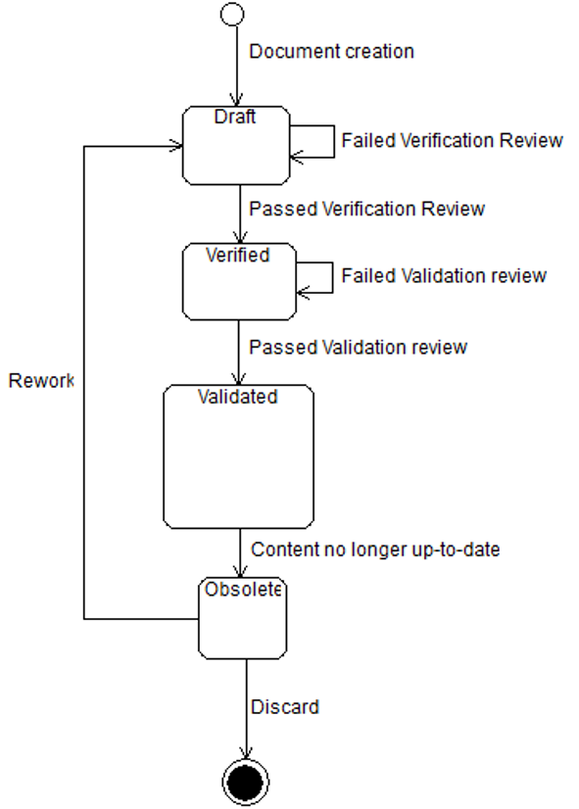
Document life cycle
Draft | When a new document is created the status “Draft” will be assigned. Only after a positive verification review the document can be promoted to “Verified” by performing a verification review. Also Obsolete documents can be assigned the status “Draft” after changes have been made to update.  Please refer to ISO26262-2 Table D.1 – Overview of verification reviews.
Verified | Status after a successful verification review according to ISO26262-2 has been performed on a document with status “Draft”.
Validated | Status after a successful validation review according to ISO26262-2 has been performed on a document with status “Verified”.
Obsolete | The status of the document should be changed to “Obsolete” when its contents no longer match the current state of the Item, System or organization it concerns, regardless of the former document state.

Maturity level assignment
At every validation review an estimate is made regarding the maturity level of this document. The estimate is based on the amount of ISO26262 requirements this document satisfies in relation to how many still have to be satisfied.
Only the person(s) responsible for the validation review may determine the maturity level of the Safety Case documents.

The maturity level will be assigned based on a scale of 0 – 4:
- Not compliant
- <50% compliant, roughly half of the aspects mentioned in ISO26262 are covered
- <75% compliant, roughly ¾ of the aspects mentioned in ISO26262 are covered
- <90% compliant, most of the aspects mentioned in ISO26262 are covered
- >90% compliant, so far to judge every aspect of the ISO26262 is covered

Abbreviated terms
List all abbreviations here which are used in this document and are not covered by ISO26262-1 Clause 2

Purpose and scope

Related documents
The initiation of the validation plan is described in ISO26262-4, clause 5. The refinements of the validation plan are described in ISO26262-4, clause 6.4.6 and clause 9.4.2.

Input documents
For creating the validation plan:
Document title | Internal ID | Revision nr | Status | Resource location
Project plan
Safety plan
Functional safety assessment plan
Functional safety concept

For refining the validation plan:
Document title | Internal ID | Revision nr | Status | Resource location
Technical safety requirements specification
HARA
Safety Goals
Functional Safety Concept

Work products
The following work products result from a validation activity:
- Validation plan (refined)
- Validation report (as a result of the evaluation of the validation plan)

Other related documents
If any other documents are used to create the Validation Plan, please note them here.
Document title | Internal ID | Revision nr | Status | Resource location

ISO26262 compliance

Maturity level indication rationale
Which requirements of ISO26262-X clause X are covered and which are not?
What is the current requirements-coverage of this document according to ISO26262. Please also describe how this is defined/calculated.

Elements and aspects of this document which are not compliant to ISO26262
Which elements are missing in this document or which elements are not conform ISO26262? Refer to ISO26262 requirements.
Provide measures to be taken to enhance compliancy to ISO26262.

Requirement | Issue | Measure | Trigger
[Example]  9.4.4 The results of the validation shall be evaluated. | Evaluation is not yet mentioned in this document. | Describe evaluation measures.  Define the evaluation in the Safety Plan. | Put on roadmap

Attendees

Name, department | Qualification | Experience

HARA input overview
Input from Item Definition

Operating situations
Operating situation | Description

Operating modes
Operating mode | Description

Environment situations
Environment situation | Description

Traffic situations
Traffic situation | Description

Hazards
Hazard | Description

Analysis
Hints:
S0  No Injuries | S1  Light and moderate injuries | S2  Severe and life-threatening injuries (survival probable) | S3  Life-threatening injuries (survival uncertain), fatal injuries
E0  Incredible | E1  Very low probability | E2  Low probability | E3  Medium probability | E4  High probability
C0  Controllable in general | C1  Simply controllable | C2  Normally controllable | C3  Difficult to control or uncontrollable
Source: ISO26262-3.7, table 1, 2 and 3 – Severity, Exposure and Controllability classes
Severity Class | Probability class | Controllability class
 |  | C1 | C2 | C3
S1 | E1 | QM | QM | QM
 | E2 | QM | QM | QM
 | E3 | QM | QM | A
 | E4 | QM | A | B
S2 | E1 | QM | QM | QM
 | E2 | QM | QM | A
 | E3 | QM | A | B
 | E4 | A | B | C
S3 | E1 | QM | QM | A
 | E2 | QM | A | B
 | E3 | A | B | C
 | E4 | B | C | D
Source: ISO26262-3.7 table 4 – ASIL Determination

Evaluation matrix
Hazard | ID | Hazardous Scenario |  |  |  | Severity  Exposure  Controllability | Rationale Severity | Rationale Exposure | Rationale Controllability | ASIL | Safety Goal
 |  | Operating situation | Operating mode | Environment situation | Traffic situation
Accident due to unintended acceleration | 1.01 | Highway | Medium Speed | Dry Road | Motorcyclists, vehicles, trucks | S - 2  E - 4  C - 1 | There is considerable speed difference. Hence the vehicle can accelerate within safe limits. But causing a collision at high speed with a motorcyclist can cause severe and life-threatening injuries. | Roads are frequently dry. The system is frequently used on the highway for comfort. The exposure to the failure is high | The controllability of the vehicle is simple. Most drivers will react by applying the brakes. This way the CC system is shut off and the vehicle is back in control of the driver | A | The system should not transfer excess power to the wheels where it causes unintended acceleration
 | 1.02 | Highway | Medium Speed | Wet Road | Motorcyclists, vehicles, trucks | S - 2  E - 4  C - 2 |  | Roads are frequently wet. The system is frequently used on the highway for comfort |  | B
 | 1.03 |  |  |  |  | S -  E -  C - |  |  |  | C
 | 1.04 |  |  |  |  | S -  E -  C - |  |  |  | D
Hazard_2 | 2.01 |  |  |  |  | S -  E -  C -

Appendix A – Review form for TSC template (Template only!!!)

Change History
Revision | Date | Author | Chapter(s) | Reason | Description
0.01 | 04-07-2016 | R. vd Boom | All | Increase usability of these documents | Processing general feedback to all template documents

Review Log
Revision | Date | Reviewer | Chapter(s) | Result | Comments
1

Notes to editor

