Safety Plan
  - Template

Project: | ISO 26262: Recommended Practice – SMARTcode
Company: | n.a.
Document Status: | Verified
Maturity Level: | <50% compliant
Author: |  | Company: |  | Role: |  | Email:
[author] |  | [company name] |  | [role] |  | [@address]
Stakeholder: |  | Company: |  | Role: |  | Email:
[stakeholder_ 1] |  | [company name] |  | [role] |  | [@address]
[stakeholder_ 2] |  | [company name] |  | [role] |  | [@address]
[stakeholder_ 3] |  | [company name] |  | [role] |  | [@address]
[stakeholder_ 4] |  | [company name] |  | [role] |  | [@address]
[stakeholder_ x] |  | [company name] |  | [role] |  | [@address]

Change History
Revision | Date | Author | Chapter(s) | Reason | Change
1 | 01-01-2016 | J. Johnsson | 1 | Content out of date | Removed completed tasks

Table of Contents
1 To do list 3
2 RASI(C) chart 3
3 Conventions 4
3.1 Document status 4
3.2 Maturity level assignment 5
4 Abbreviated terms 6
5 Purpose and scope 6
6 Related documents 6
6.1 Input documents 6
6.2 Work products 6
6.3 Other related documents 6
7 ISO26262 compliance 7
7.1 Maturity level indication rationale 7
7.2 Elements and aspects of this document which are not compliant to ISO26262 7
8 Assignment of roles / persons 9
9 References 10
10 General description 11
10.1 Introduction 11
10.2 Structure of the document 11
10.3 Background colours 11
10.4 Glossary 11
10.5 Description of the Safety Plan table 12
11 Safety Plan table 13
Appendix A – Review form for Safety Plan Template (Template only!!!) 14

To do list
This chapter shall provide a complete list of known missing elements or actions to reach the desired maturity level of this document.

RASI(C) chart
Fill in the responsibilities with regards to this document in the RASI(C) chart below.
 | Name | Tasks/Activities | Company | Email address
Responsible | James Smith |  | CompanyX | jsmith@companyx.com
Accountable
Supportive
Informed
Consulted (optional)

Name | Role | Role description
James Smith | FSM | Functional Safety Manager, responsible for the conformance of [company / department] to ISO26262.
[name] | [role] | [description]
Responsibility | Description
Responsible | The person who is ultimately responsible for the delivery of the work product. This person has to ensure the correctness, completeness, retention and availability of this document.
Accountable | The person who has ultimate accountability and approval authority. This person is legally responsible for the correct implementation according to ISO26262.
Supportive | The team or person(s) supporting carrying out the “real” work. They are committed to the completion of the work product.
Informed | Person(s) who must stay informed regarding results or actions taken but are not involved in final decision-making.
Consulted | (Optional) Those who can provide valuable input into the development of work products and are capable of determining the quality and correctness of the work product.

Conventions

Document status
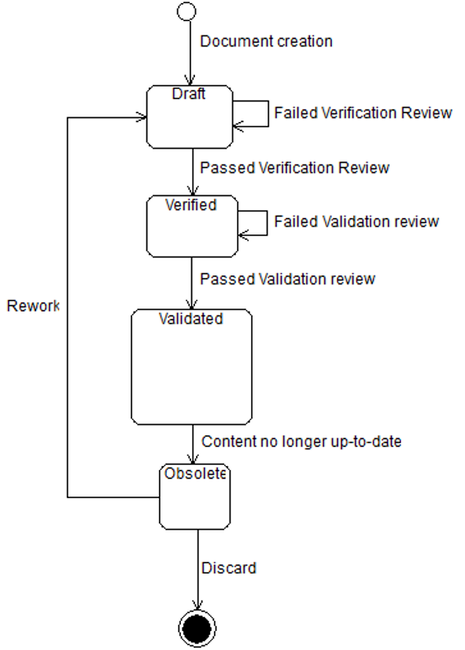
Document life cycle
Draft | When a new document is created the status “Draft” will be assigned. Only after a positive verification review the document can be promoted to “Verified” by performing a verification review. Also Obsolete documents can be assigned the status “Draft” after changes have been made to update.  Please refer to ISO26262-2 Table D.1 – Overview of verification reviews.
Verified | Status after a successful verification review according to ISO26262-2 has been performed on a document with status “Draft”.
Validated | Status after a successful validation review according to ISO26262-2 has been performed on a document with status “Verified”.
Obsolete | The status of the document should be changed to “Obsolete” when its contents no longer match the current state of the Item, System or organization it concerns, regardless of the former document state.

Maturity level assignment
At every validation review an estimate is made regarding the maturity level of this document. The estimate is based on the amount of ISO26262 requirements this document satisfies in relation to how many still have to be satisfied.
Only the person(s) responsible for the validation review may determine the maturity level of the Safety Case documents.

The maturity level will be assigned based on a scale of 0 – 4:
- Not compliant
- <50% compliant, roughly half of the aspects mentioned in ISO26262 are covered
- <75% compliant, roughly ¾ of the aspects mentioned in ISO26262 are covered
- <90% compliant, most of the aspects mentioned in ISO26262 are covered
- >90% compliant, so far to judge every aspect of the ISO26262 is covered

Abbreviated terms
List all abbreviations here which are used in this document and are not covered by ISO26262-1 Clause 2

Purpose and scope
The safety plan shall include:
a) the planning of the activities and procedures for achieving functional safety;
b) the implementation of project-independent safety activities in accordance with Clause 5 into project specific safety management;
c) the definition of the tailored safety activities, in accordance with 6.4.5, if applicable;
d) the planning of the hazard analysis and risk assessment in accordance with ISO 26262-3:2011, Clause 7;
e) the planning of the development activities, including the development and implementation of the
functional safety concept in accordance with ISO 26262-3:2011, Clause 8, the product development at the system level in accordance with ISO 26262-4, the product development at the hardware level in accordance with ISO 26262-5 and the product development at the software level in accordance with ISO 26262-6;
f) the planning of the development interface agreement (DIA) in accordance with ISO 26262-8:2011,
Clause 5, if applicable;
g) the planning of the supporting processes, in accordance with ISO 26262-8;
h) the planning of the verification activities in accordance with ISO 26262-3, ISO 26262-4, ISO 26262-5, ISO 26262-6 and ISO 26262-8:2011, Clause 9; and the planning of the safety validation activities in
accordance with ISO 26262-4:2011, Clause 9;
NOTE The verification activities are detailed in the item integration and testing plan (see ISO 26262-4) and the software verification plan (see ISO 26262-6). The validation activities are detailed in the validation plan (see ISO 26262-4). See also 6.4.3.3.
i) the planning of the confirmation reviews, the initiation of the functional safety audit(s) and the initiation of the functional safety assessment in accordance with 6.4.7 to 6.4.9;
NOTE The level of independence given in 6.4.7, and the qualifications given in 5.4.3, of the persons that carry out the confirmation measures are specified in the safety plan.
j) the planning of the analysis of dependent failures in accordance with ISO 26262-9:2011, Clause 7, if applicable, and the safety analyses in accordance with ISO 26262-9:2011, Clause 8;
k) the provision of the proven in use arguments of the candidates in accordance with ISO 26262-8:2011, Clause 14, if applicable; and
l) the provision of the confidence in the usage of software tools in accordance with ISO 26262-8:2011, Clause 11, if applicable.

Related documents
To fill in

Input documents
For creating xxxxxxxxxx:
Document title | Internal ID | Revision nr | Status | Resource location
Project plan
Safety plan
Functional safety assessment plan
Functional safety concept

For refining the xxxxxxxxxxxxx:
Document title | Internal ID | Revision nr | Status | Resource location
Technical safety requirements specification
HARA
Safety Goals
Functional Safety Concept

Work products
The following work products result from a validation activity:
- xxxxxxxx
- xxxxxxxx

Other related documents
If any other documents are used to create the Validation Plan, please note them here.
Document title | Internal ID | Revision nr | Status | Resource location

ISO26262 compliance

Maturity level indication rationale
Which requirements of ISO26262-4 clause 8 are covered and which are not?
What is the current requirements-coverage of this document according to ISO26262. Please also describe how this is defined/calculated.

Elements and aspects of this document which are not compliant to ISO26262
Which elements are missing in this document or which elements are not conform ISO26262? Refer to ISO26262 requirements.
Provide measures to be taken to enhance compliancy to ISO26262.

Requirement | Issue | Measure | Trigger
9.4.4 The results of the validation shall be evaluated. | Evaluation is not yet mentioned in this document. | Describe evaluation measures.  Define the evaluation in the Safety Plan. | Put on roadmap

Note to editor:
ISO26262-2:2011 6.4.3.5 States the following:
6.4.3.5 The safety plan shall include:
a) the planning of the activities and procedures for achieving functional safety;
b) the implementation of project-independent safety activities in accordance with Clause 5 into project specific safety management;
c) the definition of the tailored safety activities, in accordance with 6.4.5, if applicable;
d) the planning of the hazard analysis and risk assessment in accordance with ISO 26262-3:2011, Clause 7;
e) the planning of the development activities, including the development and implementation of the
functional safety concept in accordance with ISO 26262-3:2011, Clause 8, the product development at
the system level in accordance with ISO 26262-4, the product development at the hardware level in
accordance with ISO 26262-5 and the product development at the software level in accordance with
ISO 26262-6;
f) the planning of the development interface agreement (DIA) in accordance with ISO 26262-8:2011,
Clause 5, if applicable;
g) the planning of the supporting processes, in accordance with ISO 26262-8;
h) the planning of the verification activities in accordance with ISO 26262-3, ISO 26262-4, ISO 26262-5,
ISO 26262-6 and ISO 26262-8:2011, Clause 9; and the planning of the safety validation activities in
accordance with ISO 26262-4:2011, Clause 9;
NOTE The verification activities are detailed in the item integration and testing plan (see ISO 26262-4) and the
software verification plan (see ISO 26262-6). The validation activities are detailed in the validation plan (see
ISO 26262-4). See also 6.4.3.3.
i) the planning of the confirmation reviews, the initiation of the functional safety audit(s) and the initiation of
the functional safety assessment in accordance with 6.4.7 to 6.4.9;
NOTE The level of independence given in 6.4.7, and the qualifications given in 5.4.3, of the persons that carry
out the confirmation measures are specified in the safety plan.
j) the planning of the analysis of dependent failures in accordance with ISO 26262-9:2011, Clause 7, if
applicable, and the safety analyses in accordance with ISO 26262-9:2011, Clause 8;
k) the provision of the proven in use arguments of the candidates in accordance with ISO 26262-8:2011,
Clause 14, if applicable; and
l) the provision of the confidence in the usage of software tools in accordance with ISO 26262-8:2011,
Clause 11, if applicable.

Safety Plan
1 | System-/ Component name
2 | Version and date
3 | Status

Assignment of roles / persons
No. | Description | Company | Name | Short symbol | Contact details
1 | Project Manager (Item) | Company x | Mr. x | PMI_Cx | Phone:  Mobile  Fax:  eMail:
2 | Safety Manager (Item) | Company x | Mrs. Y | SMI_Cx | Phone:  Mobile  Fax:  eMail:
3 | Project Manager (EPS) | Company y | Dr. Z | PM_Cy | Phone:  Mobile  Fax:  eMail:
4 | Safety Manager (EPS / Project ABC) | Company 1 |  |  | Phone:  Mobile  Fax:  eMail:
5 | Quality Manager (EPS / Project ABC) | Company 1 |  |  | Phone:  Mobile  Fax:  eMail:
6 | R&D Manager (EPS / Project ABC) |  |  |  | Phone:  Mobile  Fax:  eMail:
… | Safety Expert  (EPS / Project ABC) (HW + HW-Test) |  |  |  | Phone:  Mobile  Fax:  eMail:
Phone:
Mobile
Fax:
eMail:
Phone:
Mobile
Fax:
eMail:

No. | Description | Author | Short symbol | Version
1 | ISO26262 Part 1 to 9: Road vehicles – Functional Safety |  |  | First edition: 2011-11
2
3
4
…

References

General description

Introduction

Structure of the document

Background colours

Glossary

No. | Number in list
Reference to standard | The referring chapter number of ISO26262
Content | Summarized content description
Objectives / Target | Short description of each objective/target. The content describes the requirements of the ISO26262 standard
Implementation of Objectives / Targets | Description and hints of the implementation in the project
Input documents | Document content, prerequisites or results which are needed as input information
Output documents | Documents, content or results which are output information
Responsibility | The responsible for the output document. For first approach as minimum info the resp. organisation has to be stated. There might be more than one.
Implementation accomplishment | As far as the implementation differs from the responsible organisation it has to be stated by whom the implementation/accomplishment relies on. There might be more than one named thus these can be named by adding rows.
Start | Planned start of the activity in accordance to the project plan
End | Planned end of the activity in accordance to the project plan
Resources [h] | If applicable: Estimated working hours for output
Note | Space for notes

Description of the Safety Plan table

No. | Reference to standard | Content | Objectives / Target | Implementation of Objectives / Targets | Input documents | Output documents | Responsibility | Implementation accomplishment | Start | End | Resources [h] | Note | Date of note
1 |  | General
 |  | Purpose
 |  | Procedure
2 | ISO26262-2 | Management of functional safety
 | ISO26262-2, Clause 5 | Management of functional safety – Overall safety management
2.1
2.2
2.3
 | ISO26262-2, Clause 6 | Management of functional safety – Safety Management during the concept phase and the product development
2.4

Safety Plan table

Appendix A – Review form for Safety Plan Template (Template only!!!)

Change History
Revision | Date | Author | Chapter(s) | Reason | Description
0.01 | 04-07-2016 | R. vd Boom | All | Increase usability of these documents | Processing general feedback to all template documents

Review Log
Revision | Date | Reviewer | Chapter(s) | Result | Comments
1

Notes to editor

